Review of Wildfire Growth Prediction Methods and Vegetation Cover Model Inputs for the 2019 Chuckegg Creek Wildfire in Alberta
REN R 906
Michael Stasuik
February 2022

Table of Contents:
Introduction …………………………………………………………………….. 2
Chuckegg Creek Wildfire………………………………………………. 5
Data Sets …………...……………………………………………………. 5
Methods ….……………………………………………………………………... 7
Assumptions and Limitations……………………..……………………. 12
Results …..……………………………………………………………………… 14
Discussion ………………………….………………………….……………….. 20
Predicted Exceeding Observed …………....…………………………… 20
Observed Exceeding Predicted ……………………………..………….. 23
Summary ..……………………………………………………………………… 28
References ……………………………………………………………………… 30
Appendix …………………………………………………..…………………… 34

Introduction:
Over the past several decades wildfires have emerged as front-page news globally. California, British Columbia, Alberta, and countless other provinces and states worldwide have become increasingly ravaged by these disasters. With the rise in global greenhouse gas emissions contributing to an increasingly warmer biosphere, and relatively effective fire suppression efforts resulting in increased fuel loads, fire behaviour has and will continue to increase in intensity and disastrousness (Flannigan et al., 2009; Williams et al., 2019). For fire management organizations to protect values at-risk, i.e., human life, communities, watersheds/soils, natural resources, and infrastructure, technology must continue developing and advancing to address the rapidly changing wildland fire environment (Duff & Tolhurst, 2015). In this paper, I evaluate the application of the Fire Behaviour Prediction (FBP) sub-system of the Canadian Forest Fire Danger Rating System to provide decision support for the effective and safe management of the 2019 Chuckegg Creek Wildfire in Alberta. I compared observed and predicted spread distances for the FBP fuel type D-1 (leafless aspen) for the Chuckegg Creek Wildfire to determine whether current fire spread prediction methods need updating. This study may have implications for other jurisdiction fire prediction metrics. It seeks to investigate the accuracy of the available vegetation information, the FBP 16 fuel type classification method’s limitations and the importance of accurate information on fire behaviour predictions.
The fire regime of the northern boreal forest is dominated by crown fires (Keeley, 2009). Crown fire regimes are characterized by infrequent, high intensity, stand-replacing wildfires which alter ecosystems and allow for new growth to take place (Bergeron et al., 2002). Deciduous and coniferous species thrive within this ecosystem, typically in a successional pattern (Leemans & Prentice, 1989). The availability of coniferous needles facilitates the crown fire spread, whereas the leaves of deciduous species such as trembling aspen do not burn as readily (Taylor & Alexander, 2019). The difference in moisture content, size, arrangement, continuity, and chemical composition of the two vegetation types results in extreme fire intensity in coniferous species and diminished fire intensity in deciduous stands (Alexander, 2010).
One successional pattern of the northern boreal forest begins with a crown fire that results in the establishment of grassland/shrubland and is typically succeeded by an aspen forest. After several decades the shade-tolerant balsam fir (Abies balsamea), black spruce (Picea mariana), and white spruce (Picea glauca) (Messier et al., 1999), out-compete the trembling aspen (Populous tremuloides) forests and comprise the overstory until another stand-replacing wildfire restarts the cycle (Korner, 1998).
Aspen are adapted to colonize disturbed areas after a high-intensity crown fire at a faster rate than coniferous species due to their tap root system (Zandonella, 2017) and wind-dispersed seeds (Errington & Pinno, 2021). Taproots allow multiple shoots to be grown from one organism, facilitating the sharing of resources and allowing for rapid colonization and growth post-disturbance (Stickney, 1989). Trembling aspen species can transport water and nutrients long distances from outside of the burned area; this allows rapid growth of shoots within the burned area before species that rely on seeds can take hold and initiate colonization (Stickney, 1989). Wind dispersed seeds allow spatial separation between parent trembling aspen trees and the growth site of new seedlings, resulting in rapid seed dispersal across burned areas.
Coniferous species such as lodgepole pine (Pinus contorta) also have adaptations such as serotinuous cones that facilitate the survival of their genetics following a wildfire. However, due to the extreme intensity of crown fires caused by fire exclusion and global warming, the post fire landscape may inhibit germination and decrease seedling survival (Beaufait, 1960). Subsequently, species such as trembling aspen will colonize the recently burned area and dominate the overstory for 60-80 years until shade-tolerant white spruce, black spruce, and balsam fir can establish in the understory and then out-compete the deciduous trees (Connell & Slatyer, 1977).
During the time between aspen establishment and coniferous succession, a significant coniferous understory becomes present and, while not observable from aerial photographs, can contribute significantly to the fuel load of the forest (Government of Alberta, 2001; Tuominen, & Pekkarinen, 2004). In addition, the northern boreal forest contains many peat wetlands, and during times of significant drought constituting very high or extreme Build Up Index (BUI) values, these wetlands dry, thereby contributing large volumes of biomass to the available fuel. This fuel type burns with a rate of spread similar to grass, helping drive the fire in a manner that is not present in non-peat areas (Government of Alberta, 2019b; Government of Alberta, 2019c). The currently used wildfire prediction techniques attempt to place unique ecosystems into predetermined categories (Taylor & Alexander, 2019). This works well for fast and straightforward predictions; however, with more research and upfront effort, prediction accuracy could be drastically enhanced with minimal follow-up effort by incorporating understory fuels based on ecosite conditions and stand age.

Chuckegg Creek Wildfire
On the night of May 29, 2019, the Chuckegg Creek Wildfire (HWF-042-2019) grew by more than 100 000 hectares, jumped the 1km wide Peace River valley, and burned into the Metis Settlement of Paddle Prairie (Town of High Level, n.d.). This unprecedented overnight growth destroyed 15 homes (Town of High Level, n.d.). Based on model outputs using the provincial FBP fuel type and Alberta Surface Land Cover (ASLC) layers in the days leading to the 29th, the community was under no imminent threat. Even with strong winds blowing directly towards the townsite, the expanse of deciduous forest between the burn and the community should have provided resistance to the fire. However, when the winds shifted to the north, the deciduous stands did not impede the spread of the fire, and the town was significantly impacted. The impetus for this study was this particular incident on the Chuckegg Creek Wildfire. While there are numerous reasons why this unexpected spread occurred, this paper will look to identify different shortcomings with the current fire prediction methods currently used by Alberta Wildfire.

Data Sets
The Alberta Vegetation Inventory (AVI) data available during the Chuckegg Creek Wildfire is based on aerial photographs from 1993, 1994, and 2006, with updates completed in 1998, 1999, 2005, 2006, 2007, and 2008 (Government of Alberta, 2019b). All the updates were done using photographs taken in 2006, indicating the 2006 aerial photography overwrote the updates completed in 1998, 1999, and 2005. The updates undertaken in 2007 and 2008 were subtracted from the total count of 2006 polygons as the 2006 data was updated. As presented in Table 1, 29.5% of the total polygons were updated in 1994, 69.6% were updated in 2006, 0.9% of polygons were updated in 2007, and 0.3% of polygons were updated in 2008. Between 25 and 11 years, separate observation and utilization of the data contained within the AVI. As previously discussed, the northern boreal is constantly evolving, making itself more susceptible to wildfires to facilitate the natural crown fire cycle. This prompts the question: Does the inability to predict the rapid-fire spread seen during the Chuckegg Creek Wildfire through deciduous forests stem from this outdated data?
In addition to the AVI, the provincial ASLC map and FBP fuel type maps were used to contrast more vegetation maps with the observed spread distances of the Chuckegg Creek Wildfire. The provincial ASLC map is a highly up-to-date, cost-effective means to record the overstory of the forest. The ASLC is updated regularly; however, it is limited in its understory assessment due to its reliance on aerial photographs. Although the photographs can be taken in the spring when there is no deciduous crown foliage, it can be challenging to differentiate understory and overstory vegetation (Tuominen & Pekkarinen, 2004). The provincial FBP fuel type layer is derived from vegetation classifications such as the provincial AVI and ASLC. This “best-fit” reclassification is dependent on the accuracy and age of the vegetation inventories and the quality of fit to an FBP fuel type.
Table 1. Summary of AVI polygon date count and percentage of the total. Photo year polygons have had the counts of more recent updates subtracted from their count.
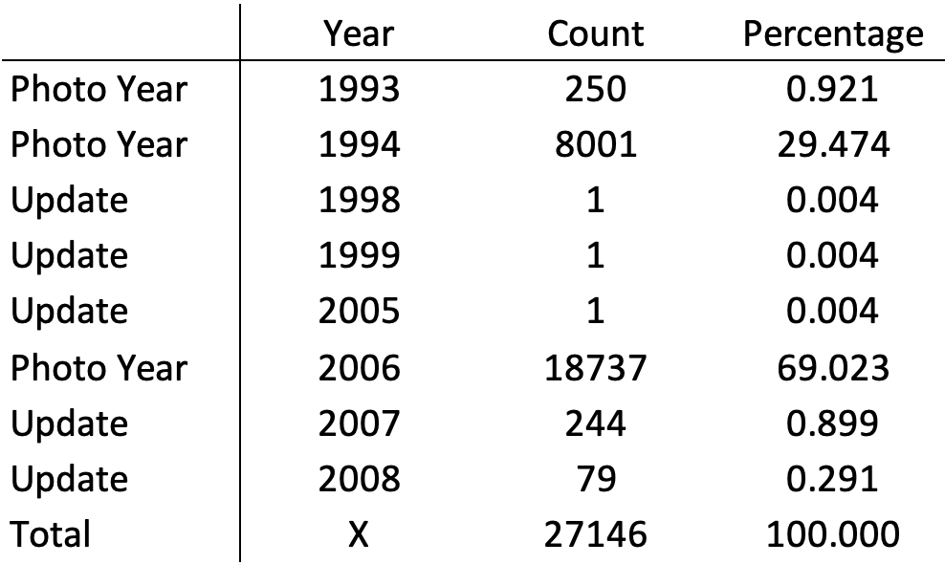

Methods:
This study began using the provincial AVI maps to complete a piecewise transect analysis of the vegetation through which the fire burned, intending to identify discrepancies between the observed spread distance and the predicted spread distance. This approach then evolved to include a piecewise analysis of the FBP fuel type layer and the ASLC maps to create additional data points.
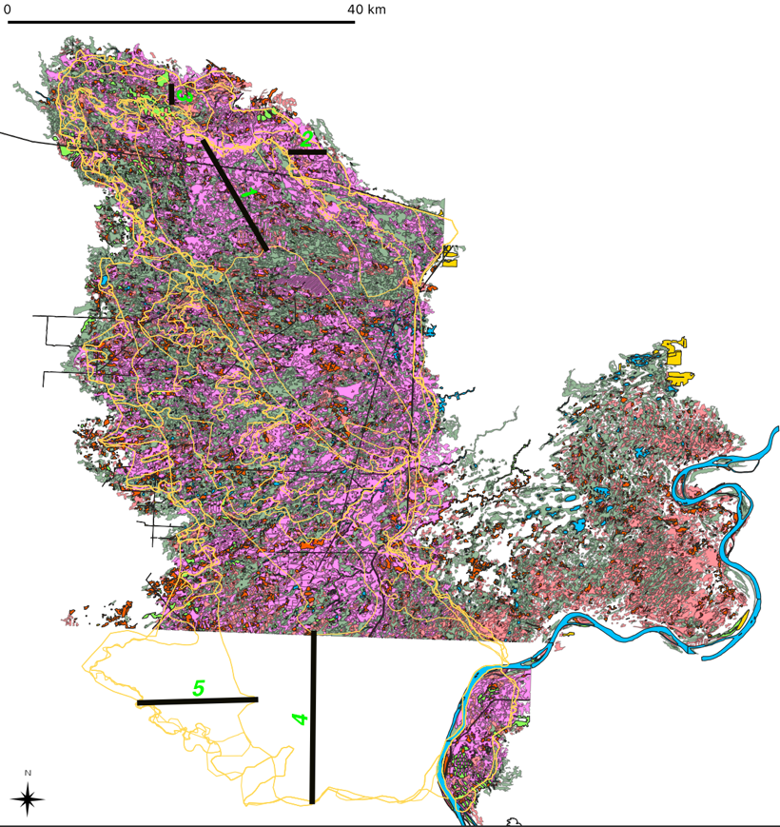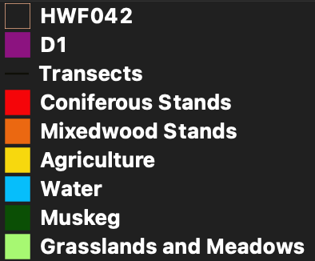
Figure 1. HWF-042-2019 progression map overlain with the AVI data available for the burn area. Note that the southwest corner does not have any available AVI data (Government of Alberta, 2019b)

Table 2. ASLC vegetation types and their corresponding FBP fuel type used in calculating spread rate.
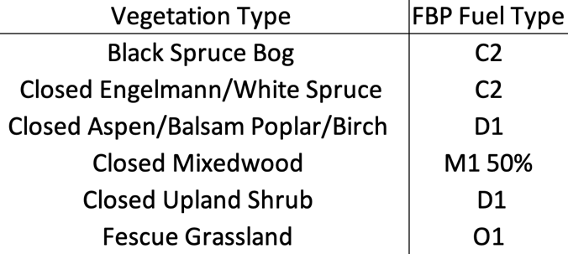
Step 1
The provincial AVI, FBP fuel type, and ASLC layers, along with a perimeter growth layer of wildfire HWF-042-2019 obtained from the Government of Alberta, were overlayed in QGIS. The AVI and perimeter growth maps were both available as image file format (tif) files; however, both the FBP and ASLC were geodatabase files and needed to be converted to tif files so they could be opened in QGIS. Once converted, the tif files were band rendered and assigned a colour. The FBP system was coloured based on the legend visible on Figures 3, 5, 6, 7, 8 and 9, while the ASLC was assigned colours at random and is summarized in the appendix. Furthermore, polygons on the AVI data set were differentiated based upon their “Fuels_1990” heading using the filter tool. The various vegetation types and their corresponding fuel types are summarized in Table 3.
Table 3. AVI vegetation classification and the corresponding FBP fuel type assigned to calculate spread distances using the REDapp model (Government of Alberta, 2019b). Muskeg is typically typed as non-fuel due to its high moisture content; however, the extreme BUI values (108.1-166.2) during the burn periods analyzed constituted availability to burn and a rate of spread most like O1a.
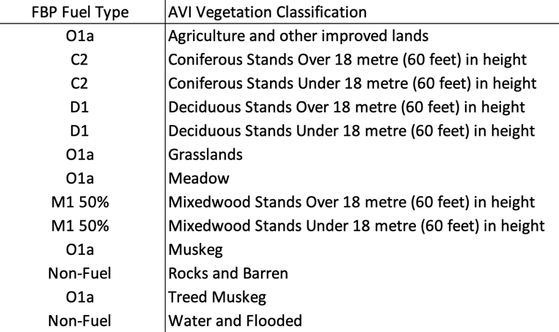
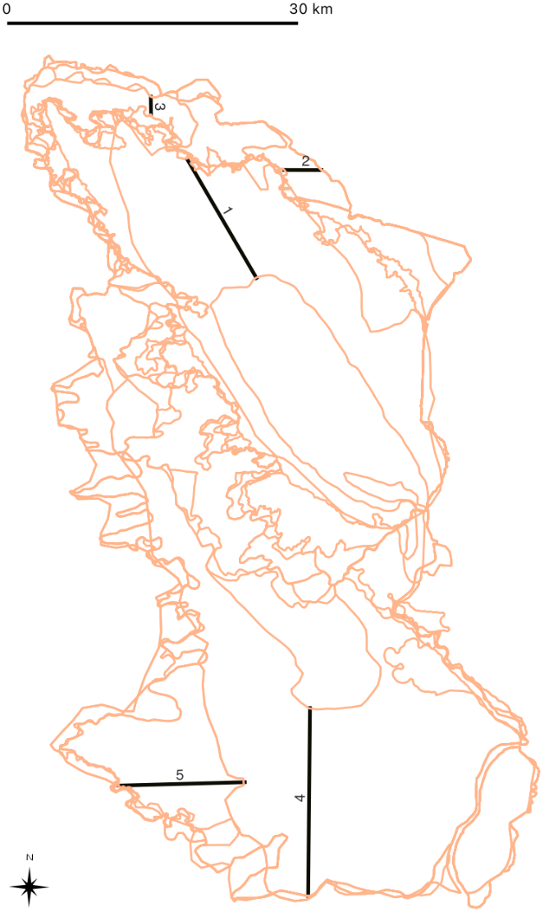
Figure 2. Progression map of HWF-042-2019 with five chosen transects marked (Government of Alberta, 2019d).

Step 2
Once all four layers were rendered accessible in QGIS and the fuel types differentiated, five transects were placed within polygons to ensure the spread was predominantly through deciduous stands (Figure 2). The positioning of these transects was placed to yield maximum spread through the D-1 fuel type. This was done to isolate FBP fuel type as the most likely driver accounting for differences in the observed and predicted spread values.
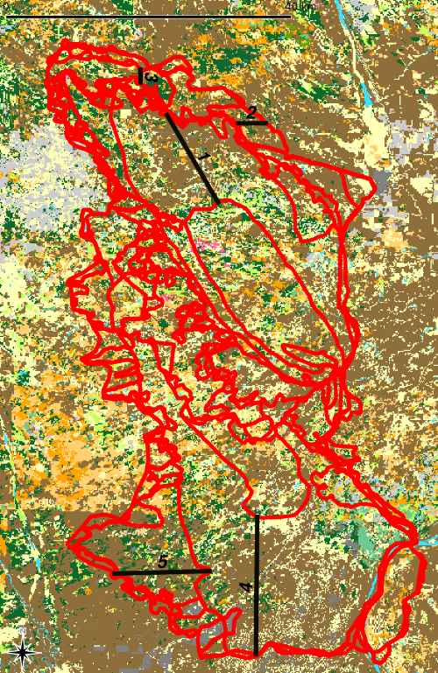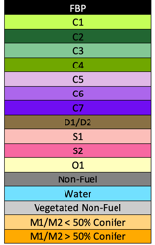
Figure 3. HWF-042-2019 progression map overlaid on the FBP map with the five chosen transects identified in black (Government of Alberta, 2019c; Government of Alberta, 2019d).

Step 3
Weather observation data for the Rocky Lane and Watt Mountain weather stations were obtained from the Provincial Fire weather Section from May 12, 2019, until June 11, 2019. Since the Rocky Lane weather station was the closest operational weather station during the burn periods through which transects were placed and provided hourly data, it was solely used for the wildfire spread. The hourly weather data was input into the REDapp application to calculate hourly Fine Fuel Moisture Code (FFMC), Duff Moisture Code (DMC), Drought Code (DC), and Initial Spread Index (ISI).. These computations were then used to calculate the rate of spread (ROS) for each classified fuel type along the transects at corresponding times and dates. Mixedwood stands in the provincial AVI layer were assigned coniferous percentages based on their overstory coniferous percentage found in the attribute table of the AVI data.
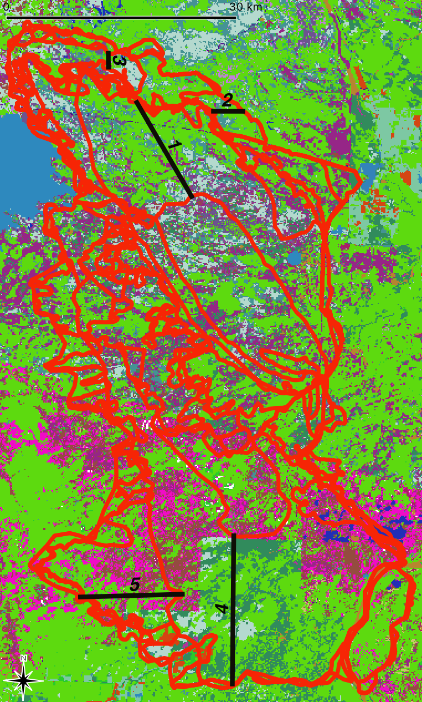
Figure 4. HWF-042-2019 progression map (red) overlaid on the ASLC map. Black lines are transects one through five. Legend for ASLC is in the appendix (Government of Alberta, 2019a; Government of Alberta, 2019d).

Step 4
Transects were divided into fuel types, and a piecewise analysis was conducted. The time required to burn through each fuel type polygon along each transect was then calculated based on the ROS calculations completed in step 3. The spread distance was calculated using the fuel types and ROS values until the observed spread distance or the observed spread time was achieved.

Step 5
Step four was repeated for each of the five transects, using the FBP and AVI or ASLC layers. First using each fuel type as they were reported, then again substituting boreal mixed wood with a 10% conifer overstory (M-1 10%) and boreal mixed wood with a 25% conifer overstory (M-1 25%) in for D-1 progressively until the predicted distance was equal to or greater than the observed distance. Finally, a comprehensive landscape-level analysis was completed. M-1 30% was used as the fuel type for the entire burn area, and all transects were retested. Transect five showed a much higher discrepancy between the observed and predicted than all other transects. As a result, the RH threshold for spread was increased to 60% rather than 45% (see assumptions and limitation), and a landscape-level analysis of C-2 was done rather than M-1 30% in an effort to achieve a predicted value similar to the observed value.

Assumptions and Limitations
When calculating spread distances using the piecewise analysis, it is crucial to identify times during which spread would not likely occur. To do this, a maximum RH value of 45% and a wind speed of 5km/hr were used as spread thresholds. Any value above 45% RH or below 5 km/hr wind speed was disregarded, and the hour they corresponded with was considered a time of no or minimal perimeter growth. For transect five, 60% RH was used in the place of 45% to address significant differences in the observed and predicted spread distances.
Additionally, the objective of this project is to identify challenges when modelling wildfire spread in the D-1 fuel type stands, therefore D-1was set as a focal point in each of the transects. No transects are 100% D-1. Other fuel types and their associated limitations in and around the transect may have contributed to differences between the observed and predicted values. To address this, transects were chosen where most of the surrounding fuels were D-1; however, not homogeneous in the pre-burn area. Vegetation types identified in the provincial AVI and ASLC did not directly correlate with the fuel types used in the FBP. As a result, the vegetation types were converted into FBP fuel types based on Table 2 and Table 3, following descriptions provided in Taylor and Alexander’s Field guide to the Canadian Forest Fire Behaviour Prediction (FBP) System (3rd ed) (2019).
The wind direction used with the piecewise analysis of each transect was aligned to support the spread of the fire along the transect. Each transect was chosen because it aligned with the predominant spread direction during the burn period. However, there was variance in the wind direction, which was not accounted for as the predictions were meant to forecast the worst-case scenario. As a result, only one uniform wind direction was used to maximize the predicted spread distance.
Sample size is also considered a limitation of this study. A single wildfire was used, and only five transects were chosen to complete the analysis. This case study does not provide enough data to identify correlations; however, it should support further investigative studies.

Results:
Transect 1
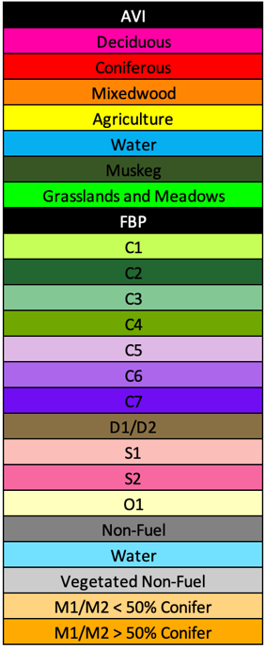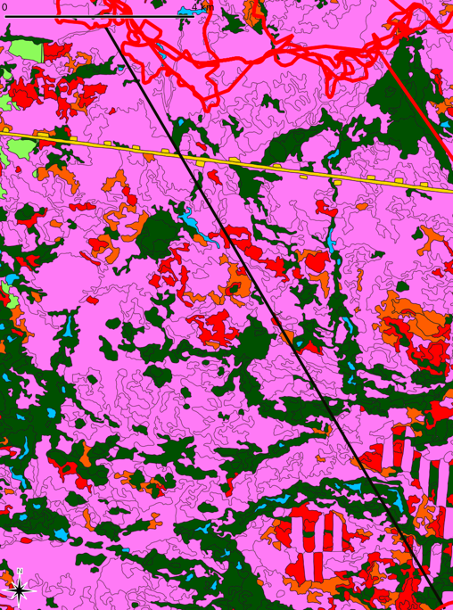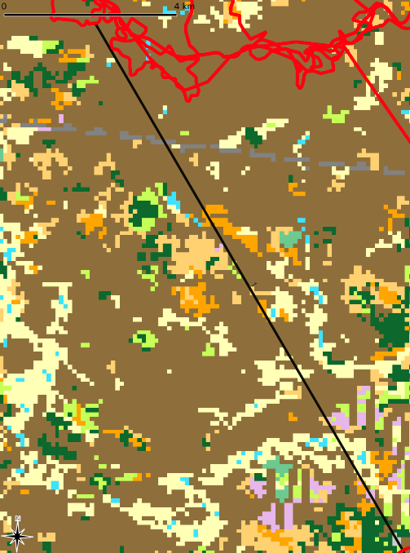
Figure 5. Transect one overlayed on the AVI (left) and FBP (right) vegetation layers. The fire spread from the southeast to the northwest over May 18, 2019, to May 20, 2019, at 1010. The black lines running from the southeast to the northwest are the transect lines, and the continuous red lines are the fire growth perimeters (Government of Alberta, 2019b; Government of Alberta, 2019c; Government of Alberta, 2019d).

In transect one, the AVI data predicted the fire would exceed the observed spread distance, reaching 14137.09 m in 1787 minutes rather than the observed 2277 minutes. Substituting M-1 10% and M-1 25% for D-1 shortened the time for the fire to reach the observed distance (Table 4). The FBP data set prediction burned 13156.10 m over 2277 minutes, 980.98m short of the observed burn. When M-1 10% was used instead of D-1 with the FBP data set, the prediction reached the observed spread distance in a time of 1390 minutes. The landscape-level analysis using M-1 30% as the only fuel type predicted the burn to match the observed spread distance in 1228 minutes.
Table 4. Transect 1 observed versus predicted burn distance over time. Only the D-1 prediction on the FBP fuel map was unable to exceed the observed spread distance.
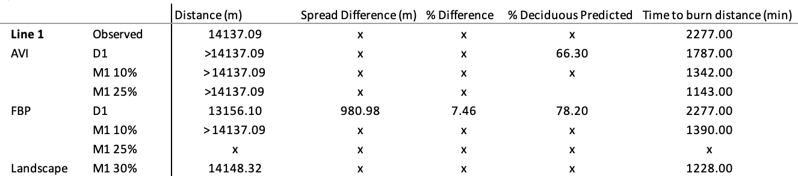
Transect 2
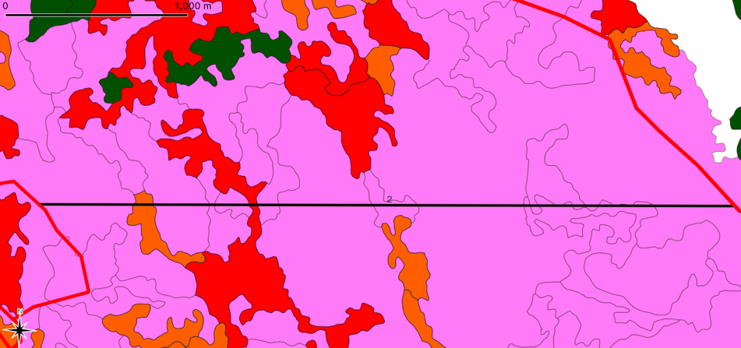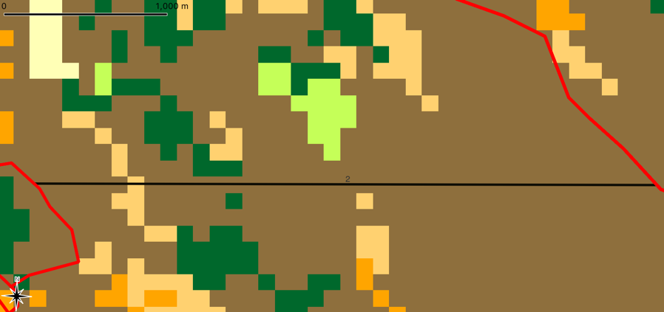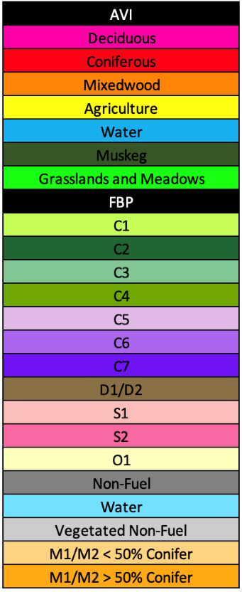
Figure 6. Transect two overlain on the AVI (left) and FBP (right) vegetation maps. The fire spread from west to east during May 29, 2019, at 0230, and May 30, 2019, at 1230. The black line running from the west to the east is transect two, and the continuous red lines at the top and bottom of the figure are the perimeter growth boundaries (Government of Alberta, 2019b; Government of Alberta, 2019c; Government of Alberta, 2019d).

Transect two once again used the AVI and FBP data sets; however, it covered a much shorter distance and occurred over a shorter time than transect one. Both the AVI and FBP data sets predicted the fire would spread the distance of the transect faster than was observed (Table 5). When the landscape level observation was used with M-1 30%, the piecewise analysis calculated the fire would burn the observed distance in 486 minutes. All three measures were much faster than the 2040 minutes between observations. No M1 substitutions were done for this transect because they would have shortened the time to burn the observed distance causing a more significant discrepancy between the observation and prediction.

Table 5. Transect 2 summary of data using AVI and FBP piecewise analysis and a landscape-level technique.
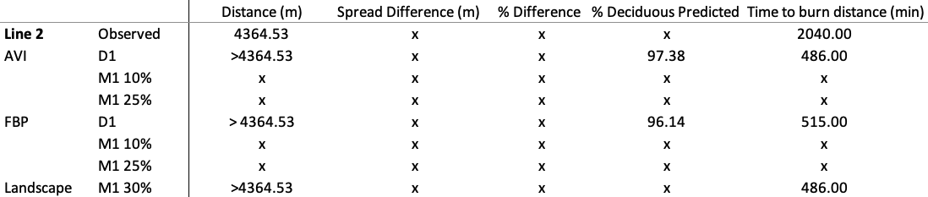
Transect 3
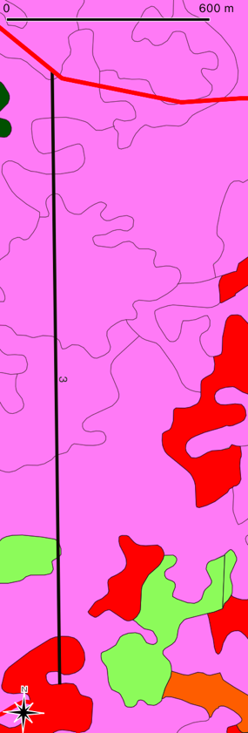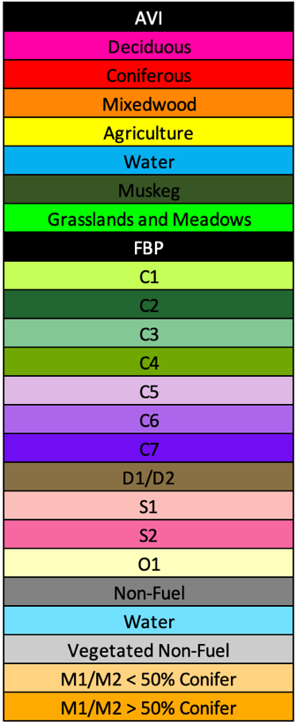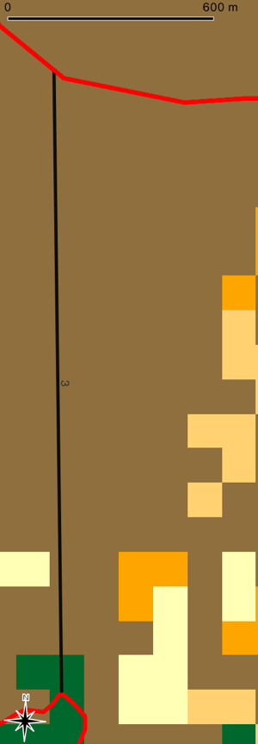

Figure 7. Transect three overlain on the AVI (left) and FBP (right) vegetation maps. The fire burned from the south to the north from 0100 on May 26, 2019, to 0446 on May 27, 2019. The black line running from the south to the north is transect three, and the continuous red lines at the top and bottom of the figure are the perimeter growth boundaries (Government of Alberta, 2019b; Government of Alberta, 2019a).

Transect three, similar to transect two, was much shorter in distance and time to burn than transects one, four and five. The piecewise analysis for transect three predicted that the fire would spread the observed distance faster than the observed time. The AVI layer predicted 384 minutes, while the FBP layer predicted 393 minutes, and the landscape analysis predicted 204 minutes. Once again, no M1 substitutions were done for this transect because they would have shortened the time to burn the observed distance causing a more significant discrepancy between the observation and prediction.
Table 6. Transect 3 summary of data using AVI and FBP piecewise analysis and a landscape-level technique.
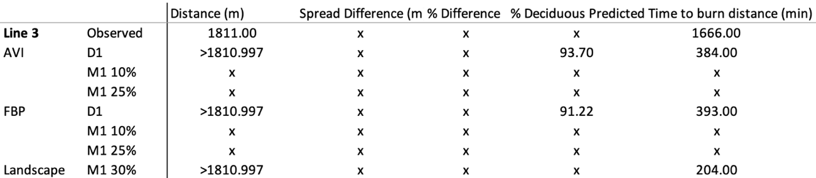

Transect 4
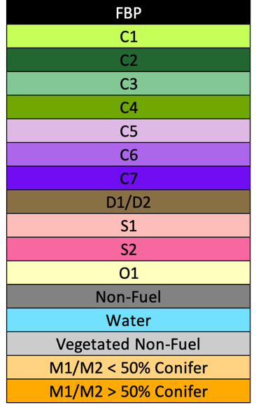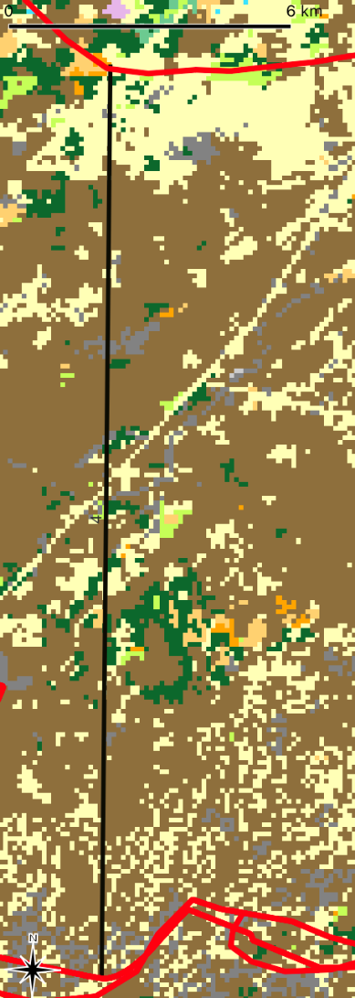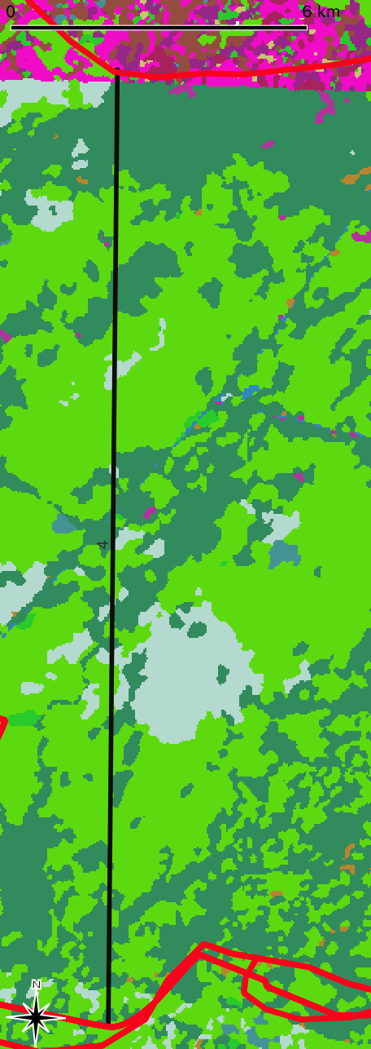
Figure 8. Transect four overlaid on FBP (left) and ASLC (right). The fire perimeter burned north to south from May 29, 2019, at 0230 to May 30, 2019, at 0400. The black line running from the south to the north is transect four, and the continuous red lines at the top and bottom of the figure are the perimeter growth boundaries (Government of Alberta, 2019a; Government of Alberta, 2019c; Government of Alberta, 2019d). The legend for the ASLC is in the appendix.

Transect four was one of two transects (transect 5), which used the ASLC rather than the AVI due to a lack of available information (Figure 1). The D-1 predicted spread distance for ASLC was less than the observed 19169.32m, reaching only 12605.56m in the 2040 minutes, and M-1 10% for ASLC exceeded the observed spread distance in a time of 1144minutes. The FBP system prediction was less than the observed spread distance over the observed 2040 minutes for the D-1 and M-1 10% analysis (12553.05m and 16283.01m, respectively), requiring an M-1 25% piecewise analysis before finally exceeding the distance in a time of 1049 minutes.

Table 7. Transect 4 summary of data using ASLC and FBP piecewise analysis and a landscape-level technique.
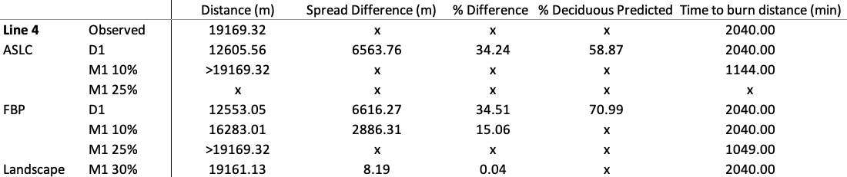

Transect 5
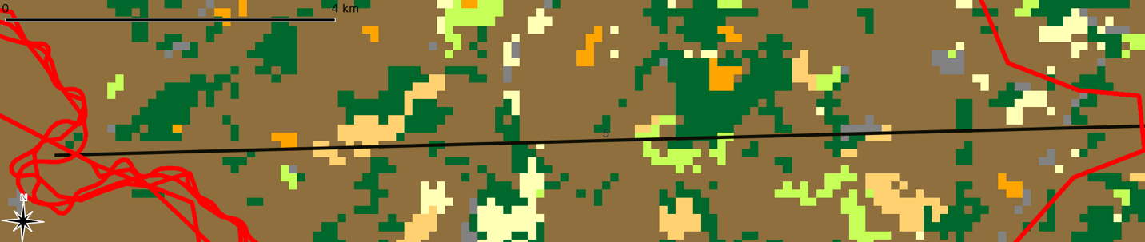
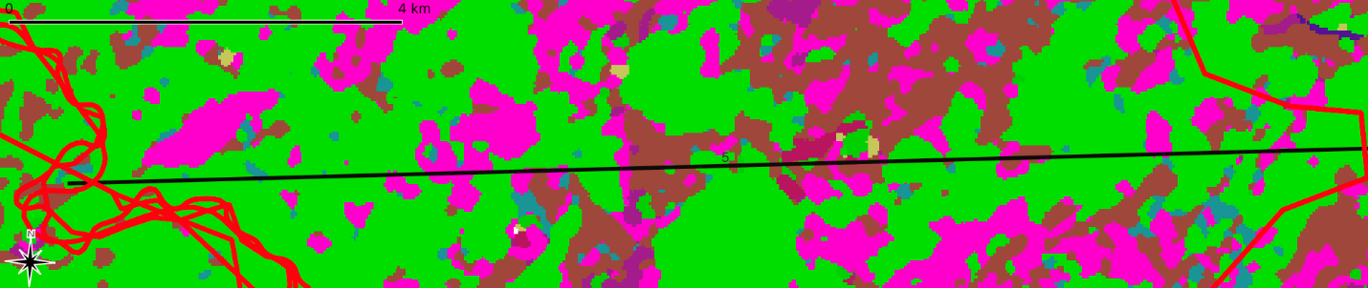
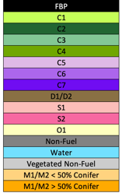
Figure 9. Transect five overlaid on the FBP (top) and ASLC (bottom) vegetation maps. The fire burned east to west from May 30, 2019, at 0400 to June 1, 2019, at 0730. The black line running from the east to west is transect five, and the continuous red lines at the left and right of the figure are the perimeter growth boundaries (Government of Alberta, 2019a; Government of Alberta, 2019c; Government of Alberta, 2019d). The legends for the ASLC map are attached in the appendix.

Transect 5’s piecewise analysis was done using the FBP and ASLC vegetation layers. According to the REDapp application with the indices presented based on the weather data from the Rocky Lane weather station and verified by another nearby weather station (Hawk Hills), the observed spread distance is not achievable in the observed time. A landscape-level analysis using boreal spruce as the only fuel type failed to burn half of the observed distance in the observed time (6228.6m). As described in the methods, a maximum RH of 45% and a wind speed of 5km/hr were required to be considered active burn periods. The RH parameters were altered for this transect to see if the predicted value could exceed the observed value, and even with RH values as high as 60% being used, the C-2 model could not exceed 11294.4m (Table 8).
Table 8. Transect 5 summary of data using ASLC and FBP piecewise analysis and a landscape-level technique.
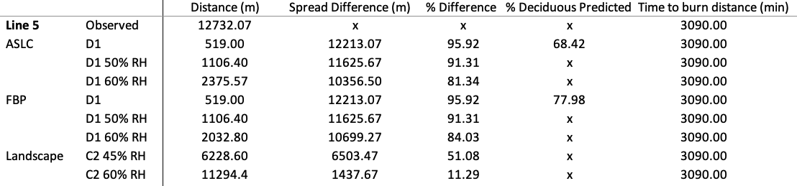

Discussion:
Fire behaviour predictions are made to mitigate potential impacts to values at risk. Ideally, they are as accurate as possible but predicted spread distances should not be exceeded by the actual spread distances due to the potential safety concerns. A study published by Drury (2019) found that the REDapp application was the most accurate of four different fire prediction applications used (BehavePlus6, REDapp, CanFIRE, CFIS). The predictions made in the study bring into question why there were such significant differences both in spread distance exceeding the observed and observed exceeding the predicted when Drury (2019) found the REDapp application to be reasonably accurate in a similar environment.

Predicted Exceeding Observed
The Chuckegg Creek Wildfire was the largest fire in Alberta during the 2019 fire season (MNP LLP, 2020). It threatened communities, caused evacuations, and was easily observable from major roadways. As a result, fire suppression measures were employed during the entirety of the burn (AA&F, May 20, 2019; AA&F, May 26, 2019; AA&F, May 29, 2019; AA&F, May 30, 2019; AA&F, May 31, 2019). Suppression tactics such as retardant air tankers, heavy helicopter buckets, medium helicopter buckets, ignition operations, bulldozer crews, as well as pump and hose crews altered the spread of the wildfire in a manner that could have resulted in inaccurate predictions in some areas.
Direct attack on a wildfire is when the flames are actioned directly through water application instead of indirect attack, which is when fires are actioned from a distance away by removing the fuels in front of the burning flame front (Plucinski, 2019b). While both strive to limit the spread of the flame front, direct attack does it on a much shorter temporal scale. Direct attack suppresses fire behaviour to immediately inhibit spread and extinguish via crews on the ground, dozer guards, and aerial operations. Indirect attack often occurs up to a kilometre or more away from the flame front, allowing a purposefully ignited fire to consume the fuels between the active flame front and an advantageous position such as a river, cutline, or road. (Plucinski, 2019a). Both types of fire suppression will influence the spread distance, and it is likely attributable to these fire suppression operations that the flames did not spread as far as predicted on transects two and three.
During the burning of transect two between May 29, 2019, at 0230 and May 30, 2019, at 1230, considerable effort occurred to contain this specific area. On the 29th and 30th, the number one control objective for the entire fire was to “Continue containment operations north of Highway 58”, a road which transect two burned two and a half kilometres north of (Figure 10; Alberta Agriculture and Forestry [AA&F], May 29, 2019; Alberta Agriculture and Forestry [AA&F], May 30, 2019). On the 29th and 30th, 80 firefighters were dedicated to this specific section of fire line, along with 13 available medium bucket ships and four heavy bucket ships (AA&F, May 29, 2019; AA&F, May 30, 2019). The Incident Action Plan does not specify where helicopters were working, so it is difficult to know how many were assigned to the area where the transect was placed. Regardless, there was a significant direct attack using bulldozer, pump, and hose efforts, as well as aerial support on the area transect two burned, at least partially explaining why the spread distance was much shorter than was predicted.
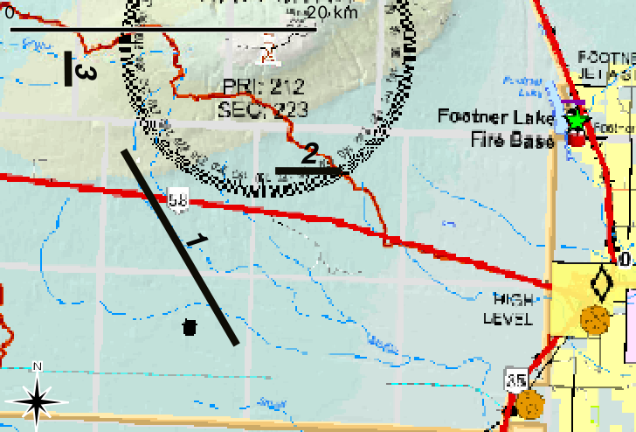
Figure 10. Map of the area Chuckegg Creek Wildfire burned through with transect 1, 2, and 3.

Similar to transect two, on May 26, 2019, when transect three burned, the number two objective on the fire was, “continue containment operations north of Highway 58”, with 60 firefighters assigned to the area as well as 13 medium helicopters and two heavy helicopters bucketing where needed (Alberta Agriculture and Forestry [AA&F], May 26, 2019). The direct attack used during the burn period of transects two and three likely caused discrepancies between the predicted and observed spread distance.
Additionally, variance in weather that was not captured by the hourly weather data may have constituted reduced spread distance for the observed fire. Weather is constantly changing; whether it is the temperature, RH, wind speed, wind direction, or precipitation, small changes can significantly impact fire spread (Alberta Agriculture and Forestry [AA&F], 2018; Thompson & Spies, 2009). Hourly data was used to create the spread models. This data cannot be considered a complete representation of the actual wind conditions due to gusts and fluctuations in speed. The distance between the weather station and the flame front may also be a source of error. The Rocky Lane weather station was relied upon due to its proximity to the fire and the availability of all dates needed. However, it was dozens of kilometres away from some of the flame fronts, meaning those areas may have had different winds, temperatures, RHs, or precipitation patterns than were recorded at the weather station.
In addition, the predominant wind direction for each transect was used as the wind direction for the entire spread of that transect. Variations in wind direction would likely have impeded or slowed the fire rate of spread, adding to the inability of the fire to reach its predicted values along transects two and three. In this study, fire spread predictions forecasted the worst-case scenario, i.e., the largest spread distance possible; therefore, predictions were made with only one wind direction supporting the fire spread when the wind direction was likely variable.

Observed Exceeding Predicted
While observing fire spread less than the predicted values suggests the suppression operations are influential, observed spread distances that exceed predicted values are less favourable due to potential impacts on values at risk. As has been already outlined, fire predictions by fire behaviour analysts are usually meant to be the worst-case scenarios, constituting the furthest a fire would spread in the given conditions (AA&F, 2018). While it is important to remember that models are only as good as the inputs programmed into them, greater accuracy in a model will result in more effective utilization of resources and safer fire suppression operations. Therefore, fire modelling and its inputs should be scrutinized and updated as often as possible. Several reasons could serve as possible explanations for why the observed was greater than predicted, including outdated vegetation information, incorrect meteorological data, assumptions, and human error. Regardless of the cause(s) of the underestimation, it must be corrected to establish priorities during fire suppression.
The AVI data used to map the FBP fuel types includes timestamps of when the most recent aerial photograph of the area was taken and if/when the last update had been done to that polygon. Fire behaviour is influenced heavily by the fuel types it burns (Taylor & Alexander, 2019). Over 11-25 years, the succession and growth of vegetation can dramatically change the understory, overstory, and the entire ecosystem. The northern boreal forest is a crown fire regime, meaning natural succession takes place continuously until a crown fire burns through the ecosystem, resetting the cycle. This cycle includes barren grasses, shrubs, deciduous, and finally coniferous forests in the northern boreal (de Groot et al., 2013). As de Groot et al. (2013) described, crown fire is driven by coniferous species such as black and white spruce or jackpine. It is possible that the fuel types labelled as deciduous and burned with extreme intensities were mixed wood stands with coniferous understories that carried the fire intensity through the aspen stands. These deciduous stands may have also contained grass and shrub surface fuels available to burn due to direct solar radiation and wind because of the open canopy resulting in rapid spread rates and large spread distances. Wildfires such as Chuckegg Creek, where fires are observed burning through D-1 stands with extreme intensity, typically occur during the spring. Strong southeasterly winds, minimal moisture content, extreme ISI values, and low fuel moisture content due to dormancy facilitate burning in all vegetation causing fire behaviour not seen throughout the rest of the fire season (Tymstra, Jain, & Flannigan, 2021).
Following extreme crown fire events, it is typical to see aspen stands dominate an area for 60-80 years before being succeeded by boreal spruce (Viereck, 1983). Over 25 years, understory conifer stands can develop significantly under an aspen overstory. The Field guide to the Canadian forest fire behaviour prediction (FBP) system (3rd ed.) (Taylor & Alexander, 2019) states no conifer understory may be present for a stand to be considered a deciduous fuel type. However, when categorizing areas as deciduous, overstory percentages as high as 20% with coniferous understory percentages of 100% are categorized as deciduous on the AVI layer (Government of Alberta, 2019b). If coniferous species are within the stand, it should be classified as a mixed wood stand (Taylor & Alexander, 2019).
The ASLC data set is a composite land cover layer derived from Landsat, SPOT, and LiDAR imaging with 30m spatial resolution for differentiating stand types, and 6m spatial resolution capabilities for wetland classifications (Government of Alberta, n.d.). The fuel type assessment is much more recent in the ASLC than the AVI yet there are also issues with understory vegetation detection. The overstory predictions generated by the ASLC can be relied upon to be accurate but categorizing unique areas into particular fuel types is not a simple task. Percentages of overstory coniferous forests differentiate between coniferous forests, mixed wood forests, and deciduous forests. Forests with a coniferous percentage as high as 20% are considered deciduous, between 20 and 70% are considered mixed wood, and above 70 percent are considered coniferous (Government of Alberta, 2019b; Government of Alberta, 2019a). In addition, aerial photography cannot accurately summarize the understory growth, creating the potential for extreme understory driven wildfires where the unassuming overstory lends itself to minimal spread rates. The province of Alberta has been proactive in photographing leaf on and leaf off to circumvent this issue using LiDAR swaths (Government of Alberta, n.d.); however, once again, assigning unique areas into predetermined FBP fuel types is not truly representative of the vegetation present and may lead to inaccuracies.
While not explicitly used for fire behaviour predictions, the provincial AVI and ASLC are sources of vegetation information that are directly used to determine fuel types. The FBP system is generated from these fuel types to predict fire behaviour; therefore, the data contained in the AVI and ASLC impacts the FBP predictions as well.
There are several problems with the current fuel classification method. As previously mentioned, a deciduous forest is characterized by having no coniferous species presence (Taylor & Alexander, 2019). The occurrence of coniferous trees in a forest drastically increases fire’s spread rate. As seen in Table 3, the higher the percentage of coniferous species within a forest, the further it could burn over a shorter time. Currently, understory growth is not factored in when categorizing vegetation plots into FBP fuel types (Government of Alberta, 2019b). An understory that differs from the overstory can result in different observed fire behaviour than is predicted. Therefore, the overstory must not be the sole factor when classifying areas into FBP fuel types. Coniferous forests succeed deciduous forests in the northern boreal, meaning understory growth of coniferous species in most deciduous stands will occur. Observations of extreme wildfire behaviour in deciduous stands on the 2019 Chuckegg Creek, 2001 Chisholm, and 2016 Horse River wildfires suggest there is a need to further our knowledge and understanding how and when these challenging events occur to better serve the province of Alberta by being more appropriately suited to protect values at risk.
In the Alberta community FireSmart guide, trembling aspen is identified as non-flammable vegetation whose growth is recommended around communities to minimize wildfire danger (Government of Alberta, 2013; Dennis, 2007). As a result, aspen stands are present around many communities which have the potential to be threatened by wildfires. In order to better protect these communities an accurate understanding of fire behaviour in trembling aspen is needed. That cannot happen if understory and successional vegetation are not considered. In addition, deciduous stands are relied upon by wildfire management organizations to slow the spread of wildfires (Fechner & Barrows, 1976). When suppression tactics are used, their effectiveness is important for the safety of those undertaking them and the success of the goals. Misinformation and underestimating wildfires cansignificantly impact values at risk.
Weather data is one final potential explanation for the observed and predicted spread distances discrepancy. REDapp uses only surface-level weather observations and does not include upper atmosphere interactions. The column of rising heat from the fire can interact with the upper atmosphere and cause increased wind and fire rate of spread on the surface which may not be documented by distant weather stations (Bakhshaii & Johnson, 2019). The transects associated with the largest spread distances, transects one, four, and five, exceeded the predicted distances. It is possible that the feedback loop between the fire and upper atmosphere during these periods of extreme burning increased the fire rate of spread, causing this discrepancy. The Rocky Lane weather station was several kilometres away from the head fire during the runs associated with the three longest transects in this study. As a result, it is possible that if feedback loops between the upper atmosphere and wildfire occurred, these weather changes would not be registered at the weather station. Transect five was the furthest transect from the Rocky Lane weather station. Although the high RH values reported were verified by the Hawk Hills weather station, isolated weather phenomena such as an upper atmosphere feedback loop may have provided conditions for burning the transect area, unavailable at the weather stations.
When the Chuckegg Creek Wildfire burned over 10,000 meters in the direction of the predominant wind, the observed burn exceeded the predicted, yet, when the fire burned less than 5,000 m in the direction of the predominant wind, the observed spread distance was shorter than the predicted. This trend was also observable temporally with transects that burned for over 1,700 minutes experienced observed spread distances greater than the predicted, while transects that burned for less than , minutes experienced shorter than predicted spread distances. In future studies with access to more transects of predominantly deciduous burns, efforts should be made to look for correlations between distance spread over time and time over spread distance. The five transects evaluated in this study provide insight into the effectiveness of the current methods and should prompt further study of the fire prediction systems used. Fires are becoming more dangerous each year, and the inaccuracies of the prediction method will continue to become more costly the longer the current prediction methods are used while remaining obsolete. Minor changes such as identifying understory vegetation and factoring in upper atmospheric weather have the potential to save money, infrastructure, and lives.

Summary:
The Chuckegg Creek Wildfire started on May 12, 2019, and burned out of control for 98 days. While the Town of High Level was saved, fifteen homes in the Paddle Prairie Metis Community were destroyed, partially due to an inability to accurately predict fire behaviour in the deciduous stands north of the community. Technology has been a tremendous ally of wildfire operations, allowing accurate weather predictions, fuel typing, and fire suppression measures. Nevertheless, technology must continue to advance to meet the increasing demands of more extreme wildfire behaviour. Due to fire exclusion and global warming, fire intensity has increased, making it less predictable and more dangerous for all values at risk. In Alberta, spring megafires containing extreme wildfire behaviour in deciduous stands may be becoming more common (Tymstra, Woolford, & Flannigan, 2019). Understanding this fire behaviour is critical to correctly assign resources to protect values at risk. More accurate predictions are attainable through updating vegetation information regularly, accounting for understory growth, and factoring in upper atmosphere weather impacts. Categorizing unique ecosystems into predefined FBP fuel types needs to be updated. Sixteen fuel types do not encompass the variety of fuels found in the northern boreal and across Canada. Forests are constantly changing; therefore, vegetation updating needs to occur regularly. The ASLC method of collecting vegetation data provides updated information, but when the AVI is relied upon, the information available may not be up to date. Models are only as good as the information, which is input, so it is of critical importance that accurate information is employed. Incorporating field observations into fire behaviour analysists forecasts can add to the current fuel mapping and should be utilized whenever possible. Although this case study has limited data, the observations suggest further research is needed on the role of D-1 on fire behaviour and spread.

References:

Alberta Agriculture and Forestry [AA&F]. (2018). FP 113 fire safety briefing.

Alberta Agriculture and Forestry [AA&F]. (2018). Incident action plan May 26.

Alberta Agriculture and Forestry [AA&F]. (2018). Incident action plan May 29.

Alberta Agriculture and Forestry [AA&F]. (2018). Incident action plan May 30.

Alexander, M. E. (2010). Surface fire spread potential in trembling aspen during summer in the Boreal Forest Region of Canada. Forestry Chronicle, 86(2), 200–212. http://doi.org/10.5558/tfc86200-2

Bakhshaii, A., & Johnson, E. (2019). A review of new generation of wildfire-atmosphere modeling. Canadian Journal of Forest Research, 49(6), 565-574. http://doi.org/10.1139/cjfr-2018-0138

Beaufait, W. (1960). Some effects of high temperatures on the cones and seeds of Jack Pine. Forest Science, 6(3), 194–198.

Bergeron, Y., Leduc, A., Harvey, B., & Gauthier, S. (2002). Natural fire regime: A guide for sustainable management of the Canadian boreal forest. Silva Fennica, 36(1). http://doi.org/10.14214/sf.553

Connell, J. H., & Slatyer, R. O. (1977). Mechanisms of Succession in Natural Communities and Their Role in Community Stability and Organization. The American Naturalist, 111(982), 1119–1144. http://doi.org/10.1086/283241

Dennis, F. (2007). Fuelbreak guidelines for forested subdivisions & communities. Colorado State Forest Service.

de Groot, W. J., Cantin, A. S., Flannigan, M. D., Soja, A. J., Gowman, L. M., & Newbery, A. (2013). A comparison of Canadian and Russian boreal forest fire regimes. Forest Ecology and Management, 294, 23–34. http://doi.org/10.1016/j.foreco.2012.07.033

Drury, S. A. (2019). Observed versus predicted fire behavior in an Alaskan black spruce forest ecosystem: An experimental fire case study. Fire Ecology, 15(1), 35. http://doi.org/10.1186/s42408-019-0053-9

Duff, T., & Tolhurst, K. G. (2015). Operational wildfire suppression modelling: A review evaluating development, state of the art and future directions. International Journal of Wildland Fire, 24(1), 735–748. http://dx.doi.org/10.1071/WF15018

Errington, R., Pinno, B. (2021). Relationships between overstory and understory components of young natural and reconstructed boreal aspen stands. Ecological Restoration, 39(3), 182-193. http://10.3368/er.39.3.182

Fechner, G., Barrows, J. 1976. Aspen stands as wildfire fuel breaks. Eisenhower Consortium Bulletin (4). 14-21.

Flannigan, M., Stocks, B., Turetsky, M., & Wotton, M. (2009). Impacts of climate change on fire activity and fire management in the circumboreal forest. Global Change Biology, 15(3), 549–560.

Government of Alberta. (n.d.). Alberta satellite land cover. Retrieved November 23, 2021, from http://geodiscover.alberta.ca/geoportal/rest/metadata/item/a1770afd24a449b0873bc4ac58496841/html

Government of Alberta. (2001). Chisholm fire final documentation report section 2. http:// open.alberta.ca/dataset/3e8819b4-c259-4d29-9c0c-6a8f5af4c3df/resource/e1183159- a6ed-4e12-8571-e758b9adc5b4/download/2001-chisholmfire-finaldocumentationreport- section02.pdf

Government of Alberta. (2013). Guidebook for community protection a guidebook for wildland/ urban interface communities. http://wildfire.alberta.ca/firesmart/documents/FireSmart- GuideCommunityProtection-Nov2013.pdf

Government of Alberta, (2019a). Alberta surface land cover map.

Government of Alberta. (2019b). Alberta vegetation inventory map.

Government of Alberta, (2019c). Fire behaviour prediction map.

Government of Alberta, (2019d). HWF-042-2019 progression map.

Keeley, J. E. (2009). Fire intensity, fire severity and burn severity: A brief review and suggested usage. International Journal of Wildland Fire, 18(1), 116–126. http://doi.org/10.1071/WF07049

Korner, C. (1998). An Introduction to the Functional Diversity of Temperate Forest Trees. In Forest Diversity and Function Temperate and Boreal Systems (pp. 13–37).

Leemans, R., & Prentice, C. (1989). Forska, a general forest succession model. Meddelanden Fran Vaxtibiologiska Institutionen, Uppsala, 2, 1–45.

Messier, C., Doucet, R., Ruel, J., Claveau, Y., Kelly, C., & Lechowicz, M. (1999). Functional ecology of advance regeneration in relation to light in boreal forests. Canadian Journal of Forest Research, 29(6), 812-823. http://doi.org/10.1139/x99-070

MNP LLP. (2020). Spring 2019 wildfire review final report. http://wildfire.alberta.ca/resources/reviews/documents/af-spring-2019-wildfire-review-final-report.pdf

Plucinski, M. P. (2019a). Contain and Control: Wildfire Suppression Effectiveness at Incidents and Across Landscapes. Current Forestry Reports, 5(1), 20–40. http://doi.org/10.1007/s40725-019-00085-4

Plucinski, M. P. (2019b). Fighting Flames and Forging Firelines: Wildfire Suppression Effectiveness at the Fire Edge. Current Forestry Reports, 5(1), 1–19. http://doi.org/10.1007/s40725-019-00084-5

Stickney, P. (1989). Seral origin of species originating in northern Rocky Mountain forests. U.S. Department of Agriculture, Forest Service, Intermountain Research Station, Unpublished Material, 7pages.

Taylor, S. W., & Alexander, M. E. (2019). Field guide to the Canadian forest fire behaviour prediction (FBP) system (3rd ed.). Edmonton, AB: Natural Resources Canada. Retrieved from http://cfs.nrcan.gc.ca/publications?id=4321

Thompson, J., & Spies, T., (2009). Vegetation and weather explain variation in crown damage within a large mixed-severity wildfire. Forest Ecology and Management, 258(7). https://doi.org/10.1016/j.foreco.2009.07.031

Town of High Level. (n.d.). Battle for Paddle Prarie. Retrieved November 26, 2021, from http://www.highlevel.ca/365/Battle-for-Paddle-Prairie

Tuominen, S., & Pekkarinen, A. (2004). Performance of different spectral and textural aerial photograph features in multi-source forest inventory. Remote Sensing of Environment, 94 (2), 256-268.

Tymstra, C., Woolford, D., Flannigan, M. (2019). Statistical surveillance thresholds for enhanced situational awareness of spring wildland fire activity in Alberta, Canada. Journal of Environmental Statistics, 9(4), http://www.jenvstat.org/v09/i04/paper.

Tymstra, C., Jain, P., Flannigan, M. (2021). Characterisation of initial fire weather conditions for large spring wildfires in Alberta, Canada. International Journal of Wildland Fire, 30, 823-835. http://doi.org/10.1071/WF21045

Viereck, L. 1983. The effects of fire in black spruce ecosystems in Alaska and northern Canada, 201-220 in R.W. Wein and D.A. MacLean, eds. The Role of Fire in Northern Circumpolar Ecosystems. John Wiley & Sons, New York.

Williams, A. P., Abatzoglou, J. T., Gershunov, A., Guzman‐morales, J., Bishop, D. A., Balch, J. K., & Lettenmaier, D. P. (2019). Observed Impacts of Anthropogenic Climate Change on Wildfire in California. Earth’s Future, 7(8), 892. http://doi.org/10.1029/2019ef001210

Zandonella, C. (2017). Tree-bark thickness indicates fire-resistance in a hotter future. Princeton University Press, Journal Article. http://www.princeton.edu/news/2017/01/11/tree-bark-thickness-indicates-fire-resistance-hotter-future

Appendix

ASLC Fuel Type Legend

